Question No 01
#include<iostream>
#include<cstring>
#include<fstream>
using namespace std;
enum accounttype
{
current,
saving
};
class Bank
{
private:
char depname[30];
char accnum[30];
accounttype type;
double balance;
static char bankname[30];
char branchcode[30];
char city[30];
static int savingcount;
static int currentcount;
public:
Bank()
{
strcpy_s(depname, "unknown");
strcpy_s(accnum, "000");
balance = 0;
strcpy_s(branchcode, "000");
strcpy_s(city, "unknown");
type = saving;
savingcount++;
}
~Bank()
{
if (type == saving)
{
savingcount--;
}
else if (type == current)
{
currentcount--;
}
}
Bank(char depname[30], char accnum[30], accounttype type01, double balance, char branchcode[30], char city[30])
{
strcpy_s(this->depname, depname);
strcpy_s(this->accnum, accnum);
strcpy_s(this->branchcode, branchcode);
strcpy_s(this->city, city);
this->balance = balance;
type = type01;
if (type01 == saving)
{
savingcount++;
}
if (type01 == current)
{
currentcount++;
}
}
void deposit(double dep)
{
balance += dep;
}
void withdraw(double widraw)
{
if (balance >= widraw)
{
balance -= widraw;
}
else
{
cout << "ERROR!!!! NOT SUFFICIENT BALANCE" << endl;
}
}
void static inputname(const char* name)
{
cout << "Enter Bank Name = ";
strcpy_s(bankname, name);
}
void static outputname(char bankname[30])
{
cout << bankname;
}
void static getAccCount()
{
cout << " Total Saving Accounts = " << savingcount << endl;
cout << " Total Current Accounts = " << currentcount << endl;
}
void dispalyacc()
{
cout << "==ACCOUNT INFO==" << endl;
cout << " Depositor Name = " << depname << endl;
cout << " Bank Name = " << bankname << endl;
cout << " City Name = " << city << endl;
cout << " Account Balance = " << balance << endl;
cout << endl;
}
const char* getAccNum()
{
return accnum;
}
void SaveToFile(ofstream& fout)
{
fout << depname << " " << accnum << " " << type << " " << balance << " " << branchcode << " " << city << endl;
}
static Bank* loadFromFile(ifstream& fin)
{
char depn[30], accn[30], branch[30], cty[30];
int t;
double bal;
if (!(fin >> depn >> accn >> t >> bal >> branch >> cty))
return nullptr;
return new Bank(depn, accn, static_cast<accounttype>(t), bal, branch, cty);
}
};
char Bank::bankname[30] = "Unknown";
int Bank::currentcount = 0;
int Bank::savingcount = 0;
int main()
{
Bank* account[100] = { nullptr };
int nAccounts = 0;
ifstream fin("accounts.txt");
while (nAccounts < 100)
{
Bank* b = Bank::loadFromFile(fin);
if (!b) break;
account[nAccounts++] = b;
}
fin.close();
int n;
do
{
system("cls");
cout << "== Main Menue ==" << endl;
cout << "1==> Create New account" << endl;
cout << "2==> Deposit Money" << endl;
cout << "3==> Withdraw Money" << endl;
cout << "4==> Display all Accounts" << endl;
cout << "5==> Delete an Account" << endl;
cout << "6==> Exit" << endl;
cin >> n;
cin.ignore();
switch (n)
{
case 1:
{
if (nAccounts >= 100)
{
cout << "Bank Is At Its Full Capacity" << endl;
break;
}
else
{
system("cls");
char name[30], accn[30], branch[30], city[30];
int t;
double bal;
cout << "Enter depositor name: ";
cin.getline(name, 30);
cout << "Enter account number: ";
cin.getline(accn, 30);
cout << "Enter type (0-Saving,1-Current): ";
cin >> t;
cout << "Enter initial balance: ";
cin >> bal;
cin.ignore();
cout << "Enter branch code: ";
cin.getline(branch, 30);
cout << "Enter city: ";
cin.getline(city, 30);
account[nAccounts++] = new Bank(name, accn, static_cast<accounttype>(t), bal, branch, city);
cout << "Account created successfully!" << endl;
system("pause");
break;
}
}
case 2:
{
system("cls");
char acc[30];
double amount;
cout << "Enter the Account number = ";
cin.getline(acc, 30);
cout << "Enter The Deposit Amount = ";
cin >> amount;
cin.ignore();
int found = 0;
for (int i = 0; i < nAccounts; i++)
{
if (account[i] && strcmp(account[i]->getAccNum(), acc) == 0)
{
account[i]->deposit(amount);
cout << "Amount Deposited Successfully" << endl;
found = 1;
break;
}
}
if (found == 0)
{
cout << "Account Not Found" << endl;
}
system("pause");
break;
}
case 3:
{
system("cls");
char acc[30];
double amount;
cout << "Enter the Account number = ";
cin.getline(acc, 30);
cout << "Enter The Withdrawl Amount = ";
cin >> amount;
cin.ignore();
bool flag = false;
for (int i = 0; i < nAccounts; i++)
{
if (account[i] && strcmp(account[i]->getAccNum(), acc) == 0)
{
account[i]->withdraw(amount);
cout << "Amount Withdraw Successful" << endl;
flag = true;
break;
}
}
if (!flag)
{
cout << "Account Not Found" << endl;
}
system("pause");
break;
}
case 4:
{
system("cls");
for (int i = 0; i < nAccounts; i++)
if (account[i])
{
account[i]->dispalyacc();
}
Bank::getAccCount();
system("pause");
break;
}
case 5:
{
system("cls");
char acc[30];
cout << "Enter Account number you want to delete = ";
cin.getline(acc, 30);
int found = 0;
for (int i = 0; i < nAccounts; i++)
{
if (account[i] && strcmp(account[i]->getAccNum(), acc) == 0)
{
delete account[i];
for (int j = i; j < nAccounts - 1; j++)
{
account[j] = account[j + 1];
}
account[nAccounts - 1] = nullptr;
nAccounts--;
cout << "Account deleted successfully" << endl;
found = 1;
break;
}
}
if (found == 0)
{
cout << "Account Not Found" << endl;
}
system("pause");
break;
}
case 6:
{
ofstream fout("accounts.txt");
for (int i = 0; i < nAccounts; i++)
if (account[i]) account[i]->SaveToFile(fout);
fout.close();
cout << "Data saved. Exiting..." << endl;
break;
}
default:
{
cout << "Invalid choice!" << endl;
system("pause");
}
}
} while (n != 6);
for (int i = 0; i < nAccounts; i++)
if (account[i])
delete account[i];
return 0;
}
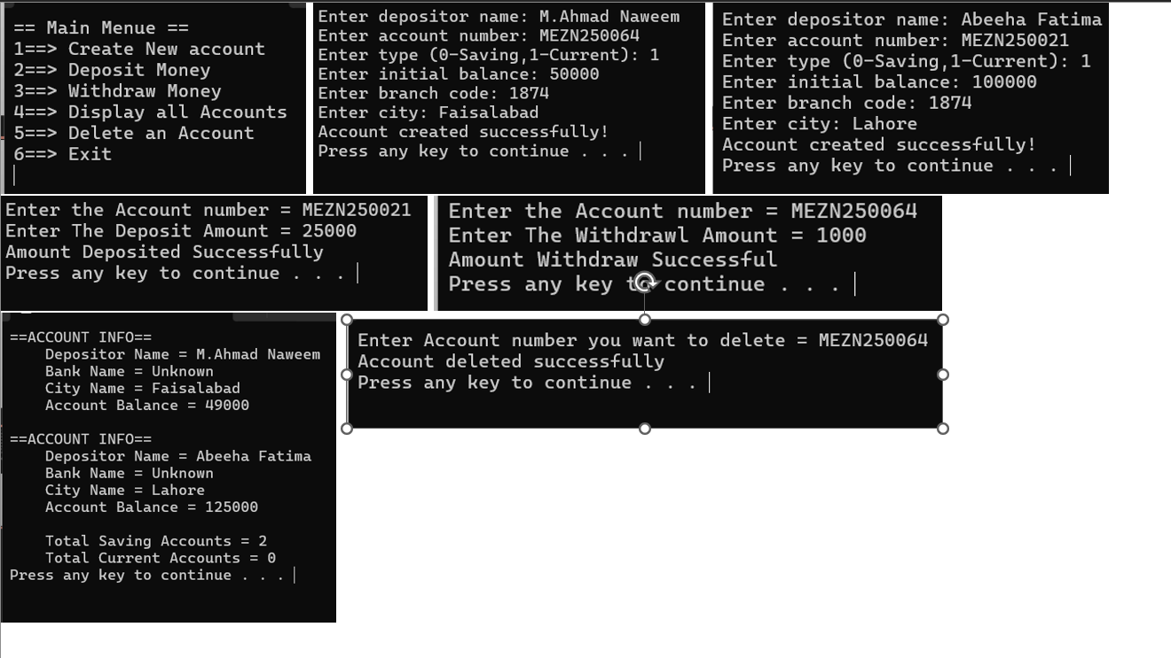

Question No 02
#include<iostream>
using namespace std;
class HotDogStand
{
private:
int idnum;
int hotdogssold;
static int totalhotdogs;
public:
HotDogStand(int id, int sold)
{
idnum = id;
hotdogssold = sold;
}
void justSold()
{
hotdogssold++;
totalhotdogs++;
}
int getHotdogsSold()
{
return hotdogssold;
}
int getIdnum()
{
return idnum;
}
static int getTotalHotdogs()
{
return totalhotdogs;
}
void displayinfo()
{
cout << "Stand ID: " << idnum << endl;
cout << "Hot Dogs Sold Today: " << hotdogssold << endl;
cout << endl;
}
};
int HotDogStand::totalhotdogs = 0;
int main()
{
HotDogStand stand1(1, 0);
HotDogStand stand2(2, 0);
HotDogStand stand3(3, 0);
cout << "=== Hot Dog Stand Management ===" << endl;
cout << endl;
stand1.justSold();
stand1.justSold();
stand1.justSold();
stand2.justSold();
stand2.justSold();
stand3.justSold();
cout << "Stand 1 sold " << stand1.getHotdogsSold() << " hot dogs" << endl;
cout << "Stand 2 sold " << stand2.getHotdogsSold() << " hot dogs" << endl;
cout << "Stand 3 sold " << stand3.getHotdogsSold() << " hot dogs" << endl;
cout << endl;
cout << "Total Hot Dogs Sold by All Stands: " << HotDogStand::getTotalHotdogs() << endl;
cout << endl;
stand1.justSold();
stand2.justSold();
stand3.justSold();
stand3.justSold();
cout << "=== After More Sales ===" << endl;
stand1.displayinfo();
stand2.displayinfo();
stand3.displayinfo();
cout << "Total Hot Dogs Sold by All Stands: " << HotDogStand::getTotalHotdogs() << endl;
return 0;
}

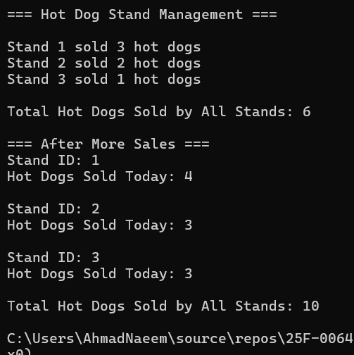

Question no 03
#include<iostream>
#include<cstring>
#include<fstream>
using namespace std;
struct Student
{
char name[30];
char cnic[20];
char gender[10];
double cgpa;
};
class Section
{
private:
Student students[40];
int studentcount;
char sectionname[20];
char classteacher[30];
public:
Section()
{
studentcount = 0;
strcpy_s(sectionname, "unknown");
strcpy_s(classteacher, "unknown");
}
Section(const char* secname, const char* teacher)
{
studentcount = 0;
strcpy_s(sectionname, secname);
strcpy_s(classteacher, teacher);
}
void editSection()
{
cout << "=== Edit Section ===" << endl;
cout << "Enter Section Name: ";
cin.ignore();
cin.getline(sectionname, 20);
cout << "Enter Class Teacher Name: ";
cin.getline(classteacher, 30);
cout << "Section Updated Successfully!" << endl;
cout << endl;
}
void addStudent()
{
if (studentcount >= 40)
{
cout << "Section is at full capacity!" << endl;
return;
}
cout << "=== Add Student ===" << endl;
cout << "Enter Student Name: ";
cin.ignore();
cin.getline(students[studentcount].name, 30);
cout << "Enter CNIC: ";
cin.getline(students[studentcount].cnic, 20);
cout << "Enter Gender: ";
cin.getline(students[studentcount].gender, 10);
cout << "Enter CGPA: ";
cin >> students[studentcount].cgpa;
studentcount++;
cout << "Student Added Successfully!" << endl;
cout << endl;
}
void updateStudent()
{
char searchname[30];
cout << "=== Update Student ===" << endl;
cout << "Enter Student Name to Update: ";
cin.ignore();
cin.getline(searchname, 30);
int found = 0;
for (int i = 0; i < studentcount; i++)
{
if (strcmp(students[i].name, searchname) == 0)
{
cout << "Current CGPA: " << students[i].cgpa << endl;
cout << "Enter New CGPA: ";
cin >> students[i].cgpa;
cout << "Student Updated Successfully!" << endl;
found = 1;
break;
}
}
if (found == 0)
{
cout << "Student Not Found!" << endl;
}
cout << endl;
}
void printList()
{
cout << "=== Section: " << sectionname << " ===" << endl;
cout << "Class Teacher: " << classteacher << endl;
cout << "Total Students: " << studentcount << endl;
cout << endl;
if (studentcount == 0)
{
cout << "No students in this section!" << endl;
}
else
{
for (int i = 0; i < studentcount; i++)
{
cout << "Student " << (i + 1) << ":" << endl;
cout << " Name: " << students[i].name << endl;
cout << " CNIC: " << students[i].cnic << endl;
cout << " Gender: " << students[i].gender << endl;
cout << " CGPA: " << students[i].cgpa << endl;
cout << endl;
}
}
}
void saveToFile(ofstream& fout)
{
fout << sectionname << " " << classteacher << " " << studentcount << endl;
for (int i = 0; i < studentcount; i++)
{
fout << students[i].name << " " << students[i].cnic << " " << students[i].gender << " " << students[i].cgpa << endl;
}
}
void loadFromFile(ifstream& fin)
{
fin >> sectionname >> classteacher >> studentcount;
for (int i = 0; i < studentcount; i++)
{
fin >> students[i].name >> students[i].cnic >> students[i].gender >> students[i].cgpa;
}
}
const char* getSectionName()
{
return sectionname;
}
};
int main()
{
int numsections = 0;
cout << "=== Student Database Management ===" << endl;
cout << "Enter number of sections: ";
cin >> numsections;
Section* sections = new Section[numsections];
ifstream fin("sections.txt");
if (fin.is_open())
{
for (int i = 0; i < numsections; i++)
{
sections[i].loadFromFile(fin);
}
fin.close();
}
int choice;
do
{
system("cls");
cout << "=== Main Menu ===" << endl;
cout << "1. Edit Section Attributes" << endl;
cout << "2. Add Student in a Section" << endl;
cout << "3. Update Student of a Section" << endl;
cout << "4. Print List of Students of a Section" << endl;
cout << "5. Print List of Sections" << endl;
cout << "6. Exit" << endl;
cout << "Enter your choice: ";
cin >> choice;
switch (choice)
{
case 1:
{
system("cls");
int secnum;
cout << "Enter section number (0-" << (numsections - 1) << "): ";
cin >> secnum;
if (secnum >= 0 && secnum < numsections)
{
sections[secnum].editSection();
}
else
{
cout << "Invalid section number!" << endl;
}
system("pause");
break;
}
case 2:
{
system("cls");
int secnum;
cout << "Enter section number (0-" << (numsections - 1) << "): ";
cin >> secnum;
if (secnum >= 0 && secnum < numsections)
{
sections[secnum].addStudent();
}
else
{
cout << "Invalid section number!" << endl;
}
system("pause");
break;
}
case 3:
{
system("cls");
int secnum;
cout << "Enter section number (0-" << (numsections - 1) << "): ";
cin >> secnum;
if (secnum >= 0 && secnum < numsections)
{
sections[secnum].updateStudent();
}
else
{
cout << "Invalid section number!" << endl;
}
system("pause");
break;
}
case 4:
{
system("cls");
int secnum;
cout << "Enter section number (0-" << (numsections - 1) << "): ";
cin >> secnum;
if (secnum >= 0 && secnum < numsections)
{
sections[secnum].printList();
}
else
{
cout << "Invalid section number!" << endl;
}
system("pause");
break;
}
case 5:
{
system("cls");
cout << "=== List of Sections ===" << endl;
for (int i = 0; i < numsections; i++)
{
cout << (i) << ". " << sections[i].getSectionName() << endl;
}
cout << endl;
system("pause");
break;
}
case 6:
{
ofstream fout("sections.txt");
for (int i = 0; i < numsections; i++)
{
sections[i].saveToFile(fout);
}
fout.close();
cout << "Data saved. Exiting..." << endl;
break;
}
default:
{
cout << "Invalid choice!" << endl;
system("pause");
}
}
} while (choice != 6);
delete[] sections;
return 0;
}

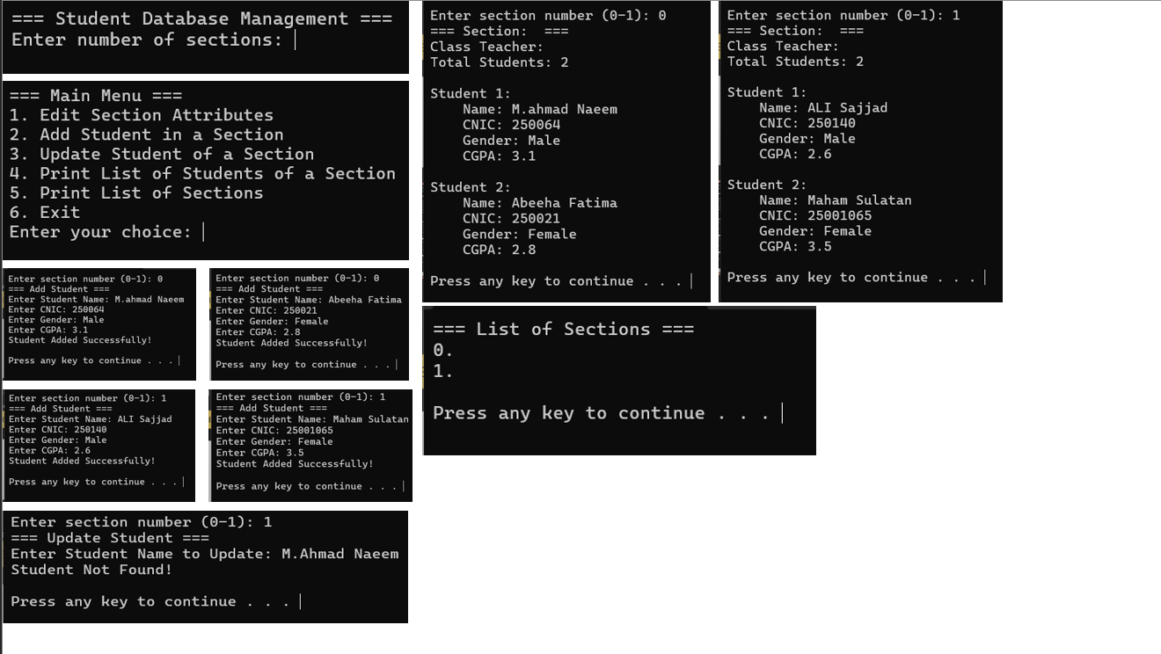

Question No 04
#include<iostream>
using namespace std;
class Tollbooth
{
private:
unsigned int totalcars;
double totalcash;
public:
Tollbooth()
{
totalcars = 0;
totalcash = 0;
}
void payingCar()
{
totalcars++;
totalcash += 50;
}
void noPayCar()
{
totalcars++;
}
void display() const
{
cout << "Total Cars: " << totalcars << endl;
cout << "Total Cash Collected: " << totalcash << " Rupees" << endl;
}
};
int main()
{
Tollbooth booth;
int choice;
cout << "=== Tollbooth Management System ===" << endl;
cout << endl;
do
{
system("cls");
cout << "=== Tollbooth Menu ===" << endl;
cout << "1. Count Paying Car" << endl;
cout << "2. Count Non-Paying Car" << endl;
cout << "3. Display Totals" << endl;
cout << "4. Exit" << endl;
cout << "Enter your choice: ";
cin >> choice;
switch (choice)
{
case 1:
{
booth.payingCar();
cout << "Paying car counted!" << endl;
system("pause");
break;
}
case 2:
{
booth.noPayCar();
cout << "Non-paying car counted!" << endl;
system("pause");
break;
}
case 3:
{
system("cls");
cout << "=== Tollbooth Statistics ===" << endl;
booth.display();
cout << endl;
system("pause");
break;
}
case 4:
{
cout << "Exiting..." << endl;
break;
}
default:
{
cout << "Invalid choice!" << endl;
system("pause");
}
}
} while (choice != 4);
return 0;
}
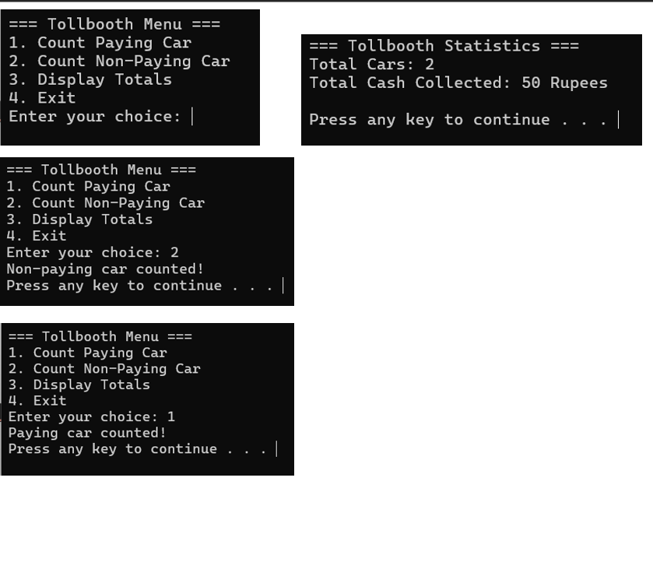

Question No 05
#include<iostream>
#include<iomanip>
using namespace std;
class Time
{
private:
int hours;
int minutes;
int seconds;
public:
Time()
{
hours = 0;
minutes = 0;
seconds = 0;
}
Time(int h, int m, int s)
{
hours = h;
minutes = m;
seconds = s;
}
void displayTime() const
{
cout << setfill('0') << setw(2) << hours << ":" << setw(2) << minutes << ":" << setw(2) << seconds;
}
Time addTime(const Time& t1, const Time& t2) const
{
Time result;
result.seconds = t1.seconds + t2.seconds;
result.minutes = t1.minutes + t2.minutes;
result.hours = t1.hours + t2.hours;
if (result.seconds >= 60)
{
result.minutes += result.seconds / 60;
result.seconds = result.seconds % 60;
}
if (result.minutes >= 60)
{
result.hours += result.minutes / 60;
result.minutes = result.minutes % 60;
}
if (result.hours >= 24)
{
result.hours = result.hours % 24;
}
return result;
}
int getHours() const
{
return hours;
}
int getMinutes() const
{
return minutes;
}
int getSeconds() const
{
return seconds;
}
};
int main()
{
const Time time1(5, 30, 45);
const Time time2(3, 25, 30);
Time time3;
cout << "=== Time Management System ===" << endl;
cout << endl;
cout << "Time 1: ";
time1.displayTime();
cout << endl;
cout << "Time 2: ";
time2.displayTime();
cout << endl;
cout << endl;
time3 = time3.addTime(time1, time2);
cout << "Sum of Time 1 and Time 2: ";
time3.displayTime();
cout << endl;
cout << endl;
cout << "Hours: " << time3.getHours() << endl;
cout << "Minutes: " << time3.getMinutes() << endl;
cout << "Seconds: " << time3.getSeconds() << endl;
return 0;
}
